COUPA RESOURCES

FEATURED RESOURCES
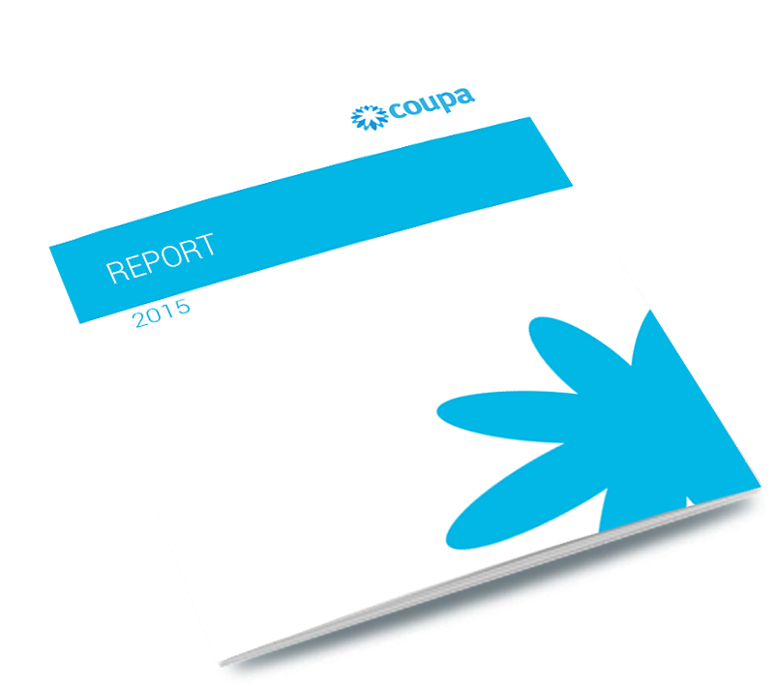

COUPA BENCHMARK REPORT
How does your organization compare? Get real KPIs from customers using Coupa.
DOWNLOAD NOW
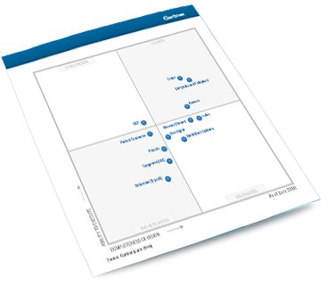

GARTNER MAGIC QUADRANT
Coupa named a leader in Gartner Magic Quadrant report on Procure-to-Pay Suites.
DOWNLOAD NOW
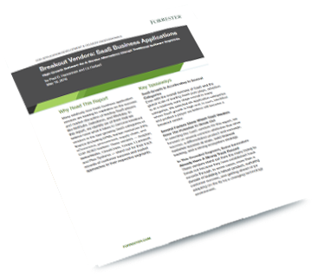

FORRESTER REPORT
Coupa 1 of 6 vendors recognized for ‘potential to disrupt the status quo’
DOWNLOAD NOW

COUPA RESOURCES
- REPORTS
- WEBINARS
- INFOGRAPHICS
- VIDEOS
- POSITION PAPERS
- DATASHEETS

GARTNER 2016 MAGIC QUADRANT
Coupa named a leader in latest Gartner Magic Quadrant report on Procure-to-Pay Suites.
A Gartner Report
LEARN MORE
BREAKOUT SAAS VENDOR REPORT
Coupa 1 of 6 vendors recognized for ‘potential to disrupt the status quo’
By Forrester Research
LEARN MORE
2015 TRAVEL AND EXPENSE MANAGEMENT NAVIGATOR
A straightforward, unbiased review of leading solutions
LEARN MORE
ONBOARDING SUPPLIER SOLUTION
Understanding the challenges, benefits and who does what
A Report by The Hackett Group
LEARN MORE
2015 EPAYABLES REPORT
175 global professionals in finance, AP and procurement weigh in on priorities, challenges and practices.
A Report by Ardent Partners
LEARN MORE
2015 POST NAVIGATOR REPORT
Detailed reviews of nine AP Automation solutions, plus a roadmap to selecting a provider.
A Report by Paystream Advisors.
LEARN MORE
MID-MARKET EPROCUREMENT
Should Mid-Market organizations invest in eProcurment systems?
Spend Matters Europe
LEARN MORE
P2P WHITEPAPER
Coupa’s industry leading cloud-based Procure-to-Pay (P2P) solution helps realize savings that directly impact the bottom line.
LEARN MORE
2014 EINVOICING BENCHMARKS
Based on a survey of 300 procurement & AP professionals.
A Report by Paystream Advisors.
LEARN MORE
P2P FOR ORACLE REPORT
Usage, results and features of e-invoicing solutions for AP.
A Report by Paystream Advisors.
LEARN MORE
GLOBAL EINVOICING
Identifying B2B strategies across borders.
A Report by Paystream Advisors.
LEARN MORE
INVOICE WORKFLOW AUTOMATION REPORT
Optimizing invoice movement and management.
A Report by Paystream Advisors.
LEARN MORE
SUPPLIER NETWORK MANAGEMENT
Managing suppliers in an integrated economy.
A Report by Paystream Advisors.
LEARN MORE
P2P FOR FINANCIAL SERVICES
What are paper processes costing you?
A Report by Paystream Advisors.
LEARN MORE
TRAVEL & EXPENSE BENCHMARK
Paystream advisor's survey of the latest trends and KPIs.
A Report by Paystream Advisors.
LEARN MORE
EINVOICING MOVES TO THE MIDDLE
Leveraging cloud-based solutions for greater efficiency and value.
A Report by Paystream Advisors.
LEARN MORE
P2P AUTOMATION FOR SMES
New opportunities for cloud-based SaaS solutions.
A Report by Paystream Advisors.
LEARN MORE
FORRESTER WAVE REPORT
Coupa awarded top scores among 11 eProcurement vendors in new report.
A Forrester Wave report
LEARN MORE
COUPA BENCHMARK REPORT
How does your organization compare? Get real KPIs from customers using Coupa.
A Coupa benchmark report
LEARN MORE
CPO RISING: WHAT'S NEW IN PROCUREMENT
270 procurement execs share best practices.
A CPO Rising report
LEARN MORE
2014 EPROCUREMENT REPORT
Market trends, uses, benefits, and capabilities.
A Report by Paystream Advisors

